Test case design
In this section, we have selected the Running Club System as the module under test. This section includes 4 Service classes and 21 methods. And for some black-box testing,we choose some typical methods for example.

For black-box testing techniques, we have chosen equivalence partitioning, boundary value analysis, decision tables, and state transition testing.

In addition to black-box testing, we will also employ the white-box testing technique of path coverage. This technique focuses on testing the different decision paths within the code to ensure that all possible outcomes of the decisions are tested.

The relevant methods to be tested are as follows:

Class | Method identifier | Method name | Parameters and type
ArticleService | Ser_Article_001 | likeArticle | Integer user_id,Integer id
ArticleService | Ser_Article_002 | getArticleById | Integer id
ArticleService | Ser_Article_003 | addArticle | String context,Integer user_id,String title
ArticleService | Ser_Article_004 | getByPageService | Integer id, Integer currentPage
ArticleService | Ser_Article_005 | isArticleLiked | TbArticleEntity tbArticleEntity
AssociationService | Ser_Asso_001 | addClub | TbAssociationEntity tbAssociationEntity
AssociationService | Ser_Asso_002 | delClub | Integer id
AssociationService | Ser_Asso_003 | findAssociationById | Integer id
AssociationService | Ser_Asso_004 | findAllClub | Integer currentPage
AssociationService | Ser_Asso_005 | updateAssociation | TbAssociationEntity tbAssociationEntity
AssociationService | Ser_Asso_006 | findUserByName | String name
FollowService | Ser_Follow_001 | follow | Integer user_id,Integer followUserID
FollowService | Ser_Follow_002 | followOrNot | Integer user_id,Integer followUserID
FollowService | Ser_Follow_003 | getCommonFollow | Integer user_id,Integer followUserID
FollowService | Ser_Follow_004 | getFollowInfo | Integer id
ManagerService | Ser_Manage_001 | joinClub | Integer as_id,Integer user_id
ManagerService | Ser_Manage_002 | quitClub | Integer as_id,Integer user_id
ManagerService | Ser_Manage_003 | ReturnAllMember | Integer as_id
ManagerService | Ser_Manage_004 | ReturnOneMember | Integer as_id,Integer user_id
ManagerService | Ser_Manage_005 | ReturnJoinedClub | Integer user_id
ManagerService | Ser_Manage_006 | updateManager | TbManagerEntity tbManagerEntity
UserService | Ser_User_001 | addUser | TbUserEntity tbUserEntity
MD5Util | Util_MD5_001 | encodeHex | byte[] bytes
MD5Util | Util_MD5_002 | decodeHex | String hexString

For the methods in ManagerService, we will perform equivalence partitioning testing.In this section,we list two examples.
For method joinClub:
Method identifier | Ser_Manage_001 | Method name | joinClub
Input condition | valid equivalence class | Number | Invalid equivalence class | Number
as_id | positive integer | 1 | no positive integer | 6
as_id | exist in database | 2 | not exist in database | 7
user_id | positive integer | 3 | no positive integer | 8
user_id | exist in database | 4 | not exist in database | 9
rank | 0 or 1 | 5 | other number | 10

In the database the as_id is from 25 to 28,user_id is from 4 to 19
Then the test cases for valid equivalence classes are:

Number | as_id | user_id | rank | Covering equivalence class | Output
1 | 26 | 10 | 0 | 1,2,3,4,5 | True
Then the test cases for invalid equivalence classes are:
Number | as_id | user_id | rank | Covering equivalence class | Output
2 | 26 | 21 | 0 | 1,2,3,5,8 | False
3 | 26 | -1 | 2 | 1,2,4,5,7 | False
4 | -1 | 10 | 0 | 5,2,3,5,4 | False
5 | 110 | 10 | 2 | 1,6,3,5,4 | False
6 | 26 | 10 | -1 | 1,2,3,4,10 | False
For method ReturnOneMember:
Method identifier | Ser_Manage_004 | Method name | ReturnOneMember
Input condition | valid equivalence class | Number | Invalid equivalence class | Number
as_id | positive integer | 1 | no positive integer | 6
as_id | exist in database | 2 | not exist in database | 7
user_id | positive integer | 3 | no positive integer | 8
user_id | exist in database | 4 | not exist in database | 9
user_id | belong to the as_id | 5 | Don't belong to the club | 10
In the database the as_id is from 25 to 28,user_id is from 4 to 19
Then the test cases for valid equivalence classes are:
Number | as_id | user_id | Covering equivalence class | Output
1 | 25 | 16 | 1,2,3,4,5 | True
Then the test cases for invalid equivalence classes are:
Number | as_id | user_id | Covering equivalence class | Output
2 | 25 | 50 | 1,2,3,9,10 | False
3 | 25 | -1 | 1,2,8,9,10 | False
4 | -1 | 16 | 6,7,3,4,10 | False
5 | 110 | 16 | 1,7,3,4,10 | False
6 | 25 | 7 | 1,2,3,4,10 | False

boundary value analysis
For the methods in ArticleService, we will perform boundary value analysis testing.In this section,we list the examples.
For method getByPageAndUserIdService:
The pages ranges from 0 to 10
parameter | Boundary value | mid value
currentPage | -1 0 1 4 5 6 | 3
Then the test cases for boundary value analysis classes are:
Number | id | currentPage | Output
1 | 4 | 3 | List<TbArticleEntity>
2 | 4 | -1 | null
3 | 4 | 0 | List<TbArticleEntity>
4 | 4 | 1 | List<TbArticleEntity>
5 | 4 | 4 | List<TbArticleEntity>
6 | 4 | 5 | List<TbArticleEntity>
7 | 4 | 6 | null
8 | -1 | 3 | null
9 | 1000 | 3 | null

Decision tables
For the method addUser in the class UserService,because this method has 5 parameters,so this method can be tested by decision tables.
Through analysing the method,the decision table is as followed.

Condition | 1 | 2 | 3 | 4 | 5 | 6
valid userName | F | T | T | T | T | T
valid phone | - | F | T | T | T | T
valid password | - | - | F | T | T | T
avator OK | - | - | - | F | T | T
valid time | - | - | - | - | F | T
Action | - | - | - | - | - | T
userName has existed | F | T | T | T | T | T
simple password | - | F | T | T | T | T
phone has existed | - | - | F | T | T | T
invalid url address | - | - | - | F | T | T
no format time | - | - | - | - | F | T
register success | F | F | F | F | F | T

Then the test cases for Decision tables classes are:
Number | userName | phone | password | avator | time | output
1 | null | 15592228631 | 2132231sd | 123.60.110.3 | 2023-6-1 | userName input error
2 | asd | 11 | 2132231sd | 123.60.110.3 | 2023-6-1 | phone error
3 | asd | 15592228631 | 1 | 123.60.110.3 | 2023-6-1 | password too short
4 | asd | 15592228631 | 2132231sd | 12321 | 2023-6-1 | url invalid
5 | asd | 15592228631 | 2132231sd | 123.60.110.3 | 2023-11 | time no format
6 | asd | 15592228631 | 2132231sd | 123.60.110.3 | 2023-6-1 | register success

State transition testing

1.5 Path coverage testing
For the method encodeHex,the path of the program is as followed
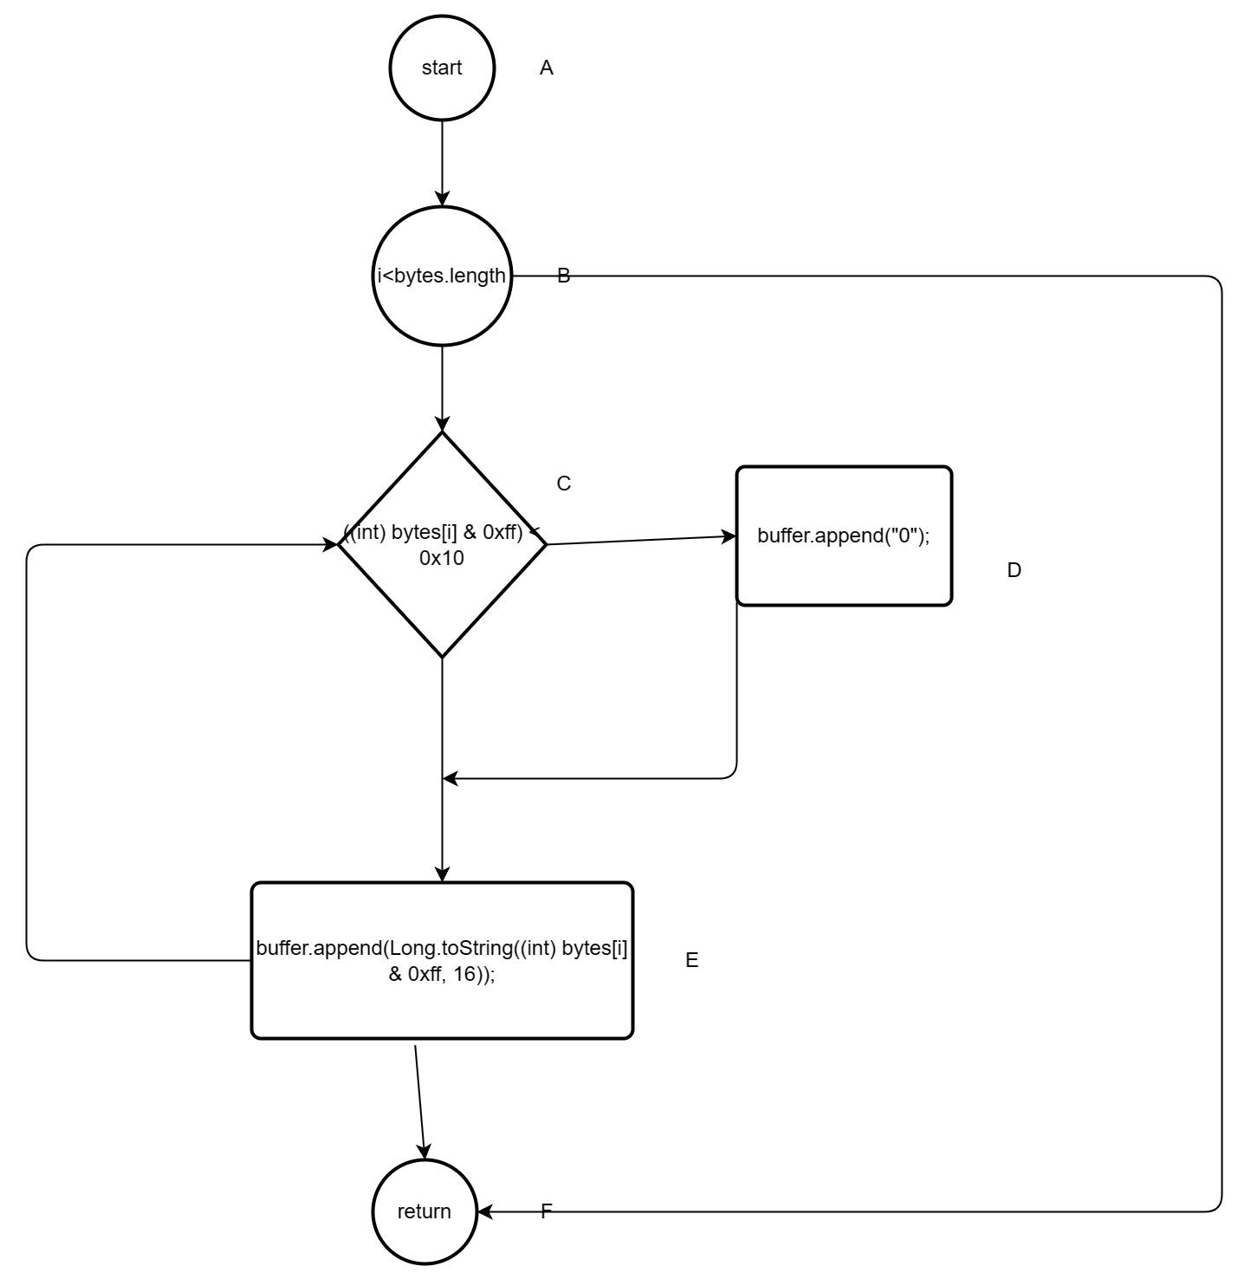
So we can get the cover path are
Number | Path
1 | A->B->F
2 | A->B->C->E->C->E->F
3 | A->B->C->D->E->F
Then the relevant test case are
Number | byte[] bytes
1 | bytes = new byte[0]
2 | bytes = {5,15,20}
3 | bytes = {20,30,40}

For the method decodeHex,the path of the program is as followed

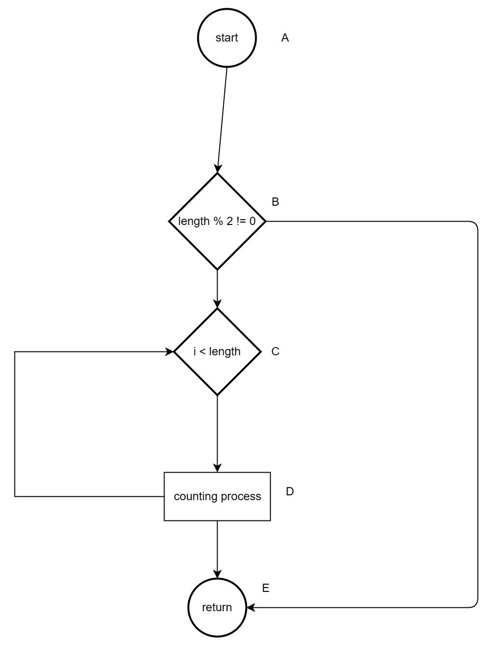
So we can get the cover path are
Number | Path
1 | A->B->E
2 | A->B->C->D->C->D->F
Then the relevant test case are
Number | String hexString
1 | ABC
2 | 414243

Test tool implementation
Based on the meticulously designed test cases provided above, we proceed with the development of test scripts utilizing the JUnit framework.

equivalence partitioning implementation
For the pervious test case,I use the JUnit design the previous case ,the codes are as following.
For method joinClub:(忘加外键了)
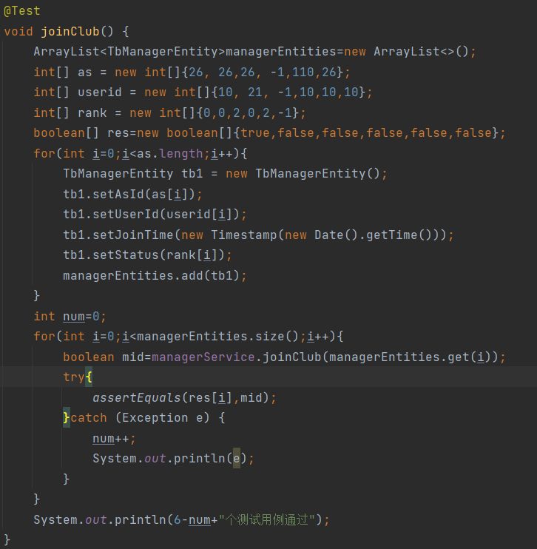
For method ReturnOneMember:
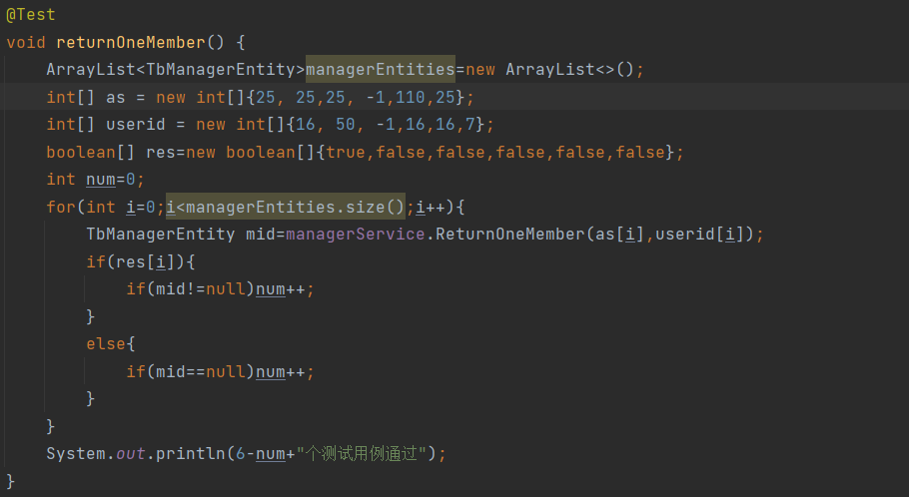

2.2 boundary value analysis implementation
For method getByPageAndUserIdService:
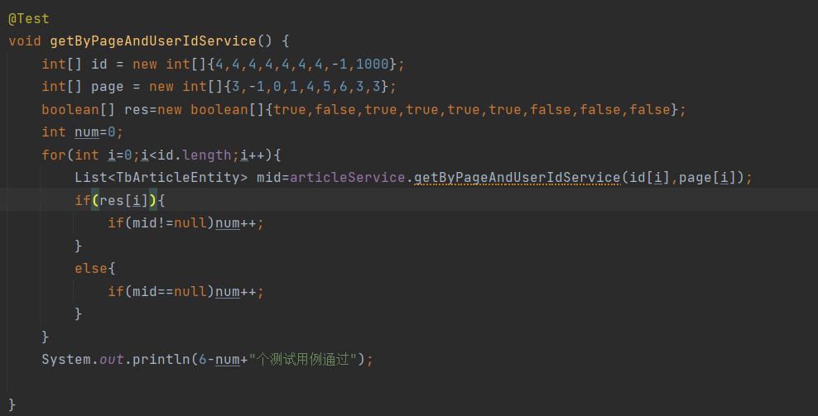

Decision tables implementation
For method addUser:
5jzx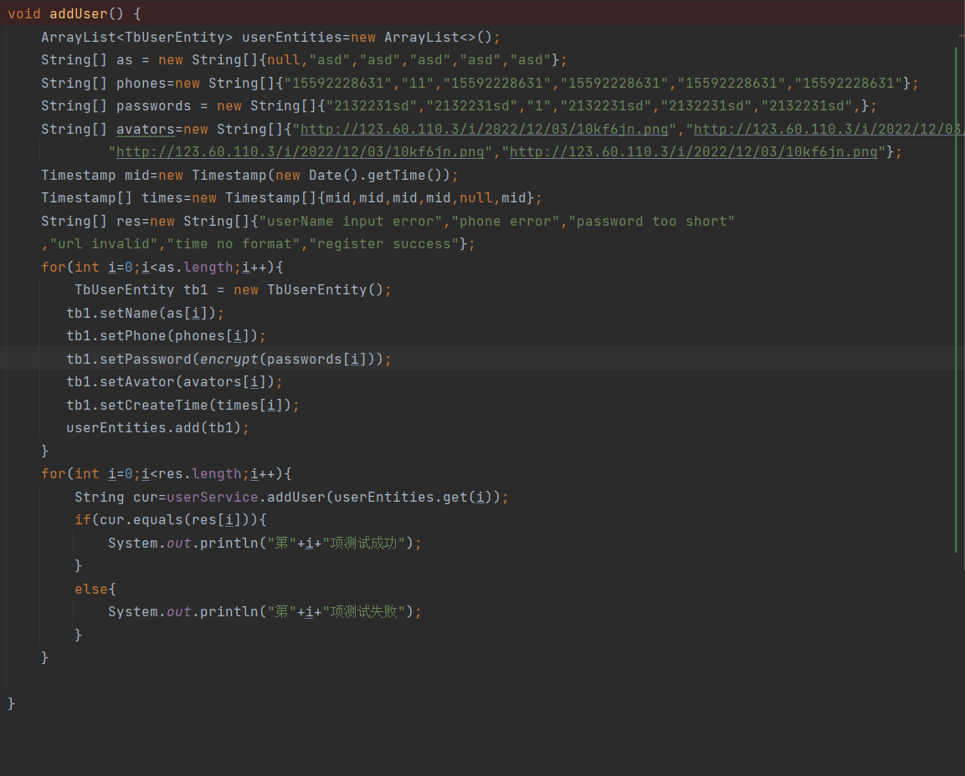

2.4 State transition testing implementation

2.5 Path coverage testing implementation
For method decodeHex
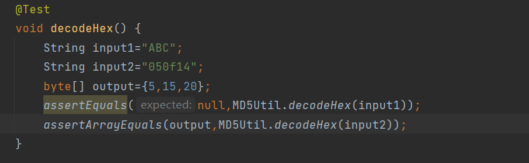

For method encodeHex:
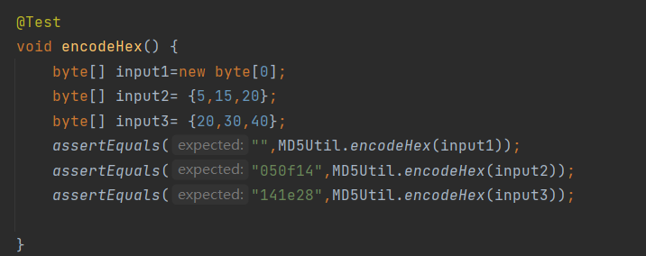

Test Results Analysis

black-box test analyse
For the ArticleServiceTest,the test result are as followed.

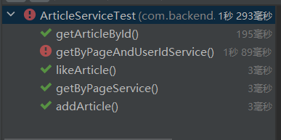
For the method getByPageAndUserIdService,it throws Exception when the test case number is 3 that currentPage is 0.
When we add the judge condition that whether the currentPage is less than zero.Then the test result after modification is as followed.
